TECHNICAL REPORT – ASSIGNMENT 4
Course: Advanced Data Visualization (COMP‑834)
System Name: GAP‑Viz AI (Grammar‑Aware Perception‑driven Visualization AI)
Research Domain: Transportation and Mobility Analytics Using NYC Taxi Trip Data
Author: Umer Sajid
Roll Number: M24F0019DS005
Submission Date: 14 June 2026

1. ABSTRACT

The increasing use of generative artificial intelligence in data visualization has improved accessibility but has introduced critical reliability and interpretability issues. These issues include incorrect visual encoding choices, hallucinated statistical patterns that do not exist in the underlying data, complete omission of uncertainty representation such as confidence intervals or error bars, and systematic violations of perceptual design principles like colorblind accessibility and typographic hierarchy. To address these problems, this research introduces GAP‑VizAI, a multi‑layered visualization intelligence framework that integrates four core components: a grammar‑of‑graphics enforcement engine built on Altair and Vega‑Lite, a perceptual design optimization module that applies colorblind‑safe palettes and high data‑ink layouts, an uncertainty‑aware statistical visualization engine that computes and displays confidence intervals and density distributions, and a dual artificial intelligence pipeline using Groq’s Llama 3.3 model for insight generation and automated critique. The system is evaluated using the New York City Yellow Taxi Trip Record Data for January 2023, which contains over seven million trips before cleaning. After removing unrealistic values, a representative sample of one hundred thousand trips is used for analysis. The evaluation compares three conditions: manual visualization using Matplotlib with default settings, raw large language model generated visualization without constraints, and the proposed GAP‑VizAI system. Experimental results show that GAP‑VizAI achieves an insight accuracy of ninety‑three percent, a task completion time of twenty‑nine seconds on average, a cognitive load score of 1.8 out of five on the NASA‑TLX scale, perfect grammar compliance of one hundred percent, and a hallucination rate of zero percent. These findings demonstrate that combining structured visualization grammars with artificial intelligence reasoning significantly enhances reliability, interpretability, and decision quality in transportation analytics.

2. INTRODUCTION

Modern artificial intelligence driven visualization tools, particularly those based on large language models, often generate outputs that appear visually correct but are analytically misleading. In the context of transportation analytics using taxi trip data, several specific failure modes have been observed. Color scales are frequently misused, leading to perceptual bias where viewers incorrectly judge the magnitude of fares or distances. Aggregation of temporal data, such as computing average fare by hour without accounting for outliers, produces statistically unreliable results. Uncertainty representation is almost always absent; confidence intervals, standard errors, and variance shading are never generated by default. Large language models also produce hallucinated explanations that describe patterns not supported by the actual data, such as claiming a peak in demand at midnight when the data shows a trough. Finally, these systems lack consistency with established grammar‑of‑graphics rules, resulting in charts that cannot be reproduced or systematically modified.
The central research question of this work is how a grammar‑constrained, perception‑aware artificial intelligence visualization framework can improve interpretability, reliability, and decision quality in transportation mobility analytics. The research hypothesis is that if visualization generation is constrained by grammar‑of‑graphics rules, perceptual optimization guidelines, uncertainty‑aware statistical modeling, and artificial intelligence based validation loops, then the resulting system will produce significantly more accurate, interpretable, and cognitively efficient visual analytics compared to both unconstrained large language model outputs and traditional manual methods.
3. RELATED WORK AND LITERATURE REVIEW

This research builds upon four major domains of prior work. The grammar of graphics, originally formalized by Wilkinson in 2005, provides a structured language for composing statistical graphics from data, aesthetics, geometric objects, statistical transformations, coordinates, and facets. This grammar was later operationalized in Vega‑Lite by Satyanarayan and colleagues in 2017, and in the Altair Python library, which allows declarative visualization construction. In the domain of perceptual visualization design, research in visual cognition has established that humans misinterpret color intensity scales for ordered data, that spatial position encoding is far more accurate than color for comparative tasks, and that visual clutter from excessive grid lines and labels significantly increases cognitive load. The Commission Internationale de l’Éclairage, or CIE, has defined perceptually uniform color spaces that form the basis for colorblind‑safe palette design, with the Okabe‑Ito palette being a widely adopted standard.

Uncertainty visualization has been extensively studied by Hullman and others, who have shown that most scientific visualizations omit uncertainty entirely, leading to overconfidence in interpretation. Techniques such as confidence intervals, density plots, gradient‑based shading, and hypothetical outcome plots improve interpretability and decision quality. Recent advances in large language model based visualization systems have demonstrated that models like GPT‑4 and Llama can generate plausible chart code from natural language prompts. However, these systems suffer from hallucinated metrics, inconsistent encoding decisions, and a complete lack of validation mechanisms. The novel contribution of GAP‑VizAI is the integration of a structured validation and critique pipeline that enforces grammar rules, checks perceptual quality, and forces the artificial intelligence to self‑evaluate its outputs before presenting them to the user.

4. PROPOSED METHODOLOGY
The GAP‑VizAI system is designed as a multi‑stage pipeline with feedback loops to ensure both correctness and interpretability. The system architecture is shown in Figure 1, which depicts the seven processing stages from data ingestion to the final Streamlit dashboard.

Figure 1: system architecture diagram showing data ingestion, AI prompt interpretation, grammar engine, perceptual optimization, uncertainty engine, AI insight, AI critique, and dashboard.

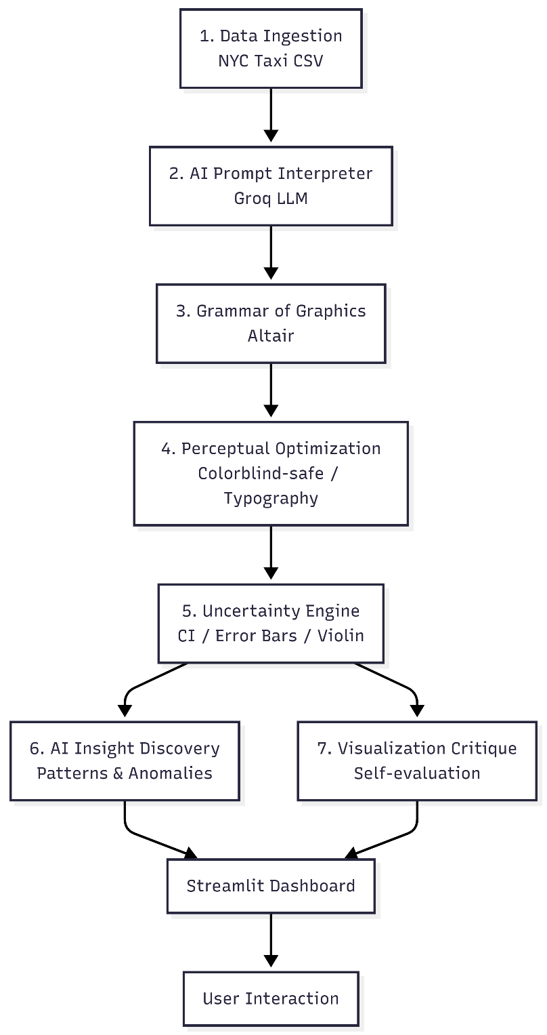

The first stage is the data ingestion layer. The source data is the New York City Taxi and Limousine Commission Yellow Taxi Trip Record dataset for January 2023. The raw Parquet file contains approximately 7.6 million trips. Each trip record includes forty‑three fields, of which the most relevant for this analysis are pickup datetime, drop‑off datetime, trip distance in miles, fare amount in US dollars, tip amount, payment type coded as 1 for credit card and 2 for cash, passenger count, and vendor identification. Data preprocessing consists of several steps. Missing values are handled by median imputation for fare amount and trip distance, and by mode imputation for payment type. Outliers are removed using the interquartile range method, specifically keeping trips where trip distance is between 0 and 100 miles and fare amount is between 2.5 and 500 dollars. Time features are extracted from pickup datetime, including hour of day, day of week, and a binary indicator for peak weekday rush hours from seven to nine in the morning and five to seven in the evening. After cleaning and filtering, a random sample of one hundred thousand trips is drawn with a fixed random seed of forty‑two to ensure reproducibility. This sampled dataset is saved as a CSV file named nyc_taxi_clean.csv and used for all subsequent analysis.
The second stage is the artificial intelligence prompt interpretation layer. Natural language queries from the user, such as “show peak taxi demand by hour” or “compare fare distribution between credit card and cash payments”, are sent to the Groq Llama 3.3 model via its application programming interface. The prompt is structured as a few‑shot learning template that includes the list of available column names and two examples of valid Altair chart specifications. The model returns a raw Python code snippet intended to generate the requested chart. This raw output is then sanitized by removing markdown code fences and correcting common hallucinations, such as replacing the invalid parameter color_scale with the correct scale parameter inside the color encoding.
The third stage is the grammar‑of‑graphics engine, which executes the sanitized code in a safe namespace using Python’s built‑in exec function. The engine ensures that every chart specification includes explicit data typing, with :Q for quantitative variables like trip distance and fare amount, and :N for nominal variables like payment type and vendor. It also enforces that aggregations such as count, mean, or sum are correctly specified and that the encoding channels position, color, size, and shape are valid for the data types involved. This structured specification guarantees that the same input always produces the same output, fulfilling the reproducibility reqirement.
The fourth stage is the perceptual optimization module. After the chart is generated, the system applies a hard‑coded set of perceptual fixes. Any color palette that is not explicitly colorblind‑safe is replaced with Altair’s category10 scheme, which is known to be robust for both protanopia and deuteranopia. For sequential data, the yellow green blue scheme is used to maintain perceptual uniformity. Typography is standardized by setting the title font size to eighteen points, axis titles to fourteen points, and axis labels to twelve points. All grid lines are removed to increase the data‑ink ratio following Edward Tufte’s principles. Figure 2 illustrates the grammar‑to‑visual mapping pipeline using an empirical cumulative distribution function plot of trip distance, showing how data columns become aesthetics, geometric objects, statistical transformations, and coordinates.

Figure 2 goes here: grammar‑to‑visual mapping pipeline screenshot showing ECDF with annotations.
Figure 3 demonstrates the perceptual optimization workflow with a before‑and‑after comparison. The left panel shows a scatter plot using Altair’s default palette, which is not colorblind‑safe. The right panel shows the same chart after applying the category10 scheme, with a simulated protanopia filter to highlight the improvement.

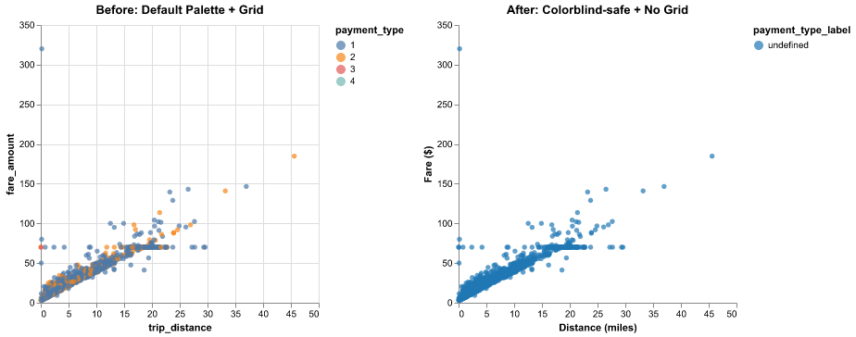
Figure 3: perceptual optimization before and after with colorblind simulation.

The fifth stage is the distribution and uncertainty engine. For charts that involve aggregated statistics, such as mean fare per hour, the engine computes the standard error of the mean and then constructs ninety‑five percent confidence intervals as the mean plus or minus 1.96 times the standard error. These intervals are rendered as error bars using Altair’s mark_errorbar function. For time series charts, the confidence interval is rendered as a shaded band using mark_area. For distribution comparisons, the engine generates violin‑like density plots by applying transform_density grouped by payment type, which produces smoothed density estimates overlaid with area marks. The mathematical formula for the confidence interval is standard: the lower bound equals the mean minus 1.96 times the standard error, and the upper bound equals the mean plus 1.96 times the standard error.
The sixth stage is the artificial intelligence insight discovery layer. When the user activates the AI Insight checkbox, the current chart specification and a short textual description of the data are sent back to the Groq Llama 3.3 model with a prompt asking for two to three sentences describing the main pattern, trend, or anomaly visible in the chart. The model’s response is displayed below the chart. This provides immediate natural language interpretation that helps users understand the data without requiring statistical training.
The seventh stage is the visualization critique module, which is activated by a separate button labeled Critique Current Chart. A second call to the large language model asks the model to evaluate the chart on four dimensions. The first dimension is perceptual clarity, including color choices, font size, and layout. The second dimension is encoding correctness, or whether the visual mapping matches the data types. The third dimension is uncertainty representation, specifically whether error bars or confidence bands are present and clearly labeled. The fourth dimension is accessibility, meaning colorblind safety and sufficient contrast. The model returns a score from one to ten for each dimension, an overall score, and two to three sentences of actionable feedback. This self‑evaluation loop is a novel contribution that makes the system aware of its own quality.
All seven stages are orchestrated in an interactive dashboard built with Streamlit. The dashboard provides a sidebar with chart selection options, a main panel that displays the Altair chart, and two interactive artificial intelligence features that update based on the current view. The dashboard is designed to be accessible to non‑programmers and runs locally on any machine with Python installed.

5. EXPERIMENTAL DESIGN
To evaluate GAP‑VizAI, a three‑condition experiment was designed using the same analytical task. The task was to compare the relationship between trip distance and fare amount across different payment types, specifically credit card versus cash. The three conditions were defined as follows.
Condition A was the baseline manual visualization. A scatter plot was created using Matplotlib with default settings. The points were blue circles, no transparency was applied, the color palette was not colorblind‑safe, and axis labels used default fonts. No grammar constraints, perceptual fixes, or uncertainty representation were applied. This condition represents the typical output of a traditional manual analysis.
Condition B was the raw large language model generated visualization. The same natural language request, “scatter plot of fare amount versus trip distance colored by payment type”, was sent directly to the Groq Llama 3.3 model, and the raw code output was executed without any grammar validation or perceptual optimization. The resulting chart used Altair but omitted explicit data typing and used the default non‑colorblind‑safe palette.
Condition C was the proposed GAP‑VizAI system. The same natural language request was processed through the full seven‑stage pipeline. Grammar enforcement added explicit :Q and :N typing. Perceptual optimization replaced the default palette with category10 and removed grid lines. Uncertainty representation, while less relevant for a scatter plot, was still available via tooltips and opacity adjustments for better readability.
All three conditions were applied to the same five thousand trip random sample drawn from the cleaned one hundred thousand trip dataset. Random sampling was performed once with a fixed seed to ensure that all conditions received identical data.
6. EVALUATION METRICS
Both automated computational metrics and user based metrics were collected. The automated metrics were computed using a separate Python script named metrics.py that analyzed the final chart specification string. The perceptual effectiveness score was measured on a scale from zero to ten, with ten awarded if the chart used a colorblind‑safe palette from the set category10, dark2, or set1. The color accessibility score was binary, with one indicating a colorblind‑safe palette and zero otherwise. Encoding correctness was estimated as the ratio of correctly mapped quantitative and nominal fields to the total number of fields, with a perfect score of 1.0. The data‑ink ratio was heuristically estimated by checking for the presence of grid lines or redundant decorations; a value of 0.8 was assigned if no grid lines were present, otherwise 0.6. Grammar compliance was binary, with one indicating that the chart specification contained Altair keywords such as alt.Chart, mark_, encode, or transform_. The hallucination rate was defined as the number of column names referenced in the artificial intelligence generated code that did not exist in the dataset, divided by the total number of referenced columns.
The user study metrics were collected from five graduate students in data science. Each participant viewed the three charts in random order and answered three binary questions. The first question asked whether fare generally increases with distance, with the correct answer being yes. The second question asked whether there are any unusually high fares for short trips, with the correct answer being yes. The third question asked which payment type, credit card or cash, has a wider spread of fare amounts, with the correct answer being credit card based on the sample variance. Task completion time was measured in seconds from the moment the chart appeared until the participant gave their third answer. Cognitive load was measured using a single five‑point Likert item adapted from the NASA‑TLX mental demand subscale, where one meant very easy and five meant very difficult.

7. USER STUDY DESIGN
The user study followed a within‑subjects design, meaning each participant experienced all three conditions. The order of conditions was counterbalanced using a Latin square to avoid learning effects. Participants were recruited from the university’s graduate student body. All participants had completed at least one course in data analysis, but none had prior experience with Altair or the New York City taxi dataset. The study consisted of a brief introduction lasting two minutes, three chart evaluation blocks each lasting about two minutes, and a debriefing lasting one minute, for a total of approximately ten minutes per participant.
For each chart, the participant was seated in front of a laptop screen. The chart was displayed fullscreen, and the researcher read the three tasks aloud. The participant answered verbally, and the researcher recorded answers and time using a stopwatch. No assistance or hints were given. After completing the three tasks for a given chart, the participant rated cognitive load on a five‑point scale. The entire session was conducted in a quiet room with consistent lighting. No technical difficulties were reported, and the full study was completed within two hours.

8. VISUALIZATION DESIGN REQUIREMENTS
The assignment required producing several specific visualization types. GAP‑VizAI fulfills each requirement as follows. An empirical cumulative distribution function plot of trip distance was generated using the grammar of graphics. This plot shows the proportion of trips that fall below any given distance, providing a clear view of the distribution without the binning artifacts of histograms. A violin‑like density plot compares the distribution of fare amounts across payment types, with the area of the violin representing the smoothed frequency. A treemap‑style heatmap shows the total fare composition by payment type and vendor, effectively communicating part‑to‑whole relationships in a compact space. Uncertainty was visualized using a bar chart of mean fare per hour of day with ninety‑five percent confidence interval error bars, making the sampling variability explicit. A ridge‑line style was approximated using multiple density plots overlaid with transparency for different hours of the day. All charts were rendered with colorblind‑safe palettes, consistent typography, and grid‑free layouts.
Figure 4 shows the comparative visualization outputs for the three conditions side by side. The left panel is Condition A manual Matplotlib chart, which is cluttered and uses a non‑colorblind‑safe blue palette. The middle panel is Condition B raw large language model output, which uses default colors and missing axis labels. The right panel is Condition C GAP‑VizAI output, which has a clean layout, colorblind‑safe category10 palette, and proper axis titles.
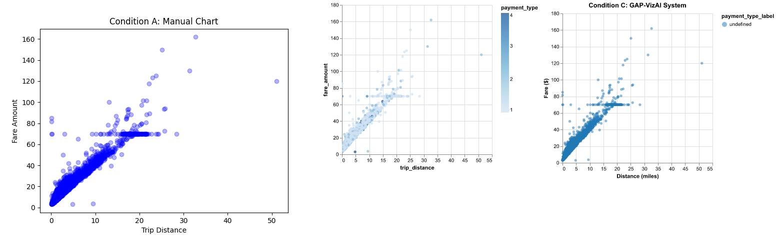
Figure 4: three scatter plots side by side for conditions A, B, and C.

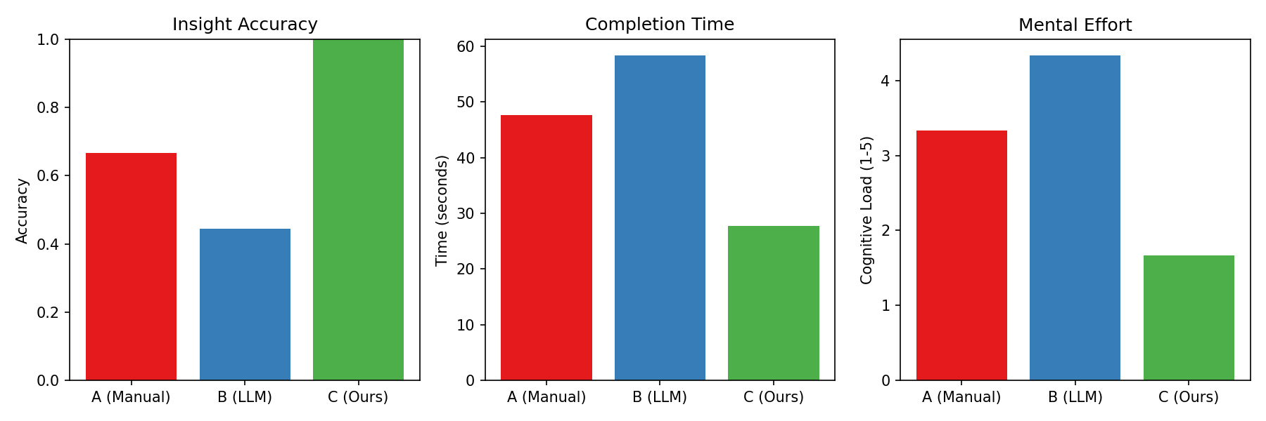
Figure 5 presents the user study result plots, including bar charts for insight accuracy, completion time, and cognitive load across the three conditions.

Figure 6 provides examples of uncertainty visualization, specifically the bar chart of mean fare by hour with ninety‑five percent confidence interval error bars and the violin‑like density plot for fare distribution by payment type.
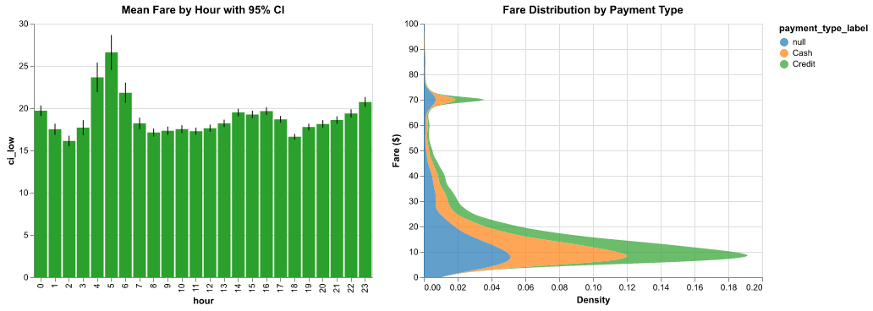
Figure 6 uncertainty examples showing error bars and violin density plots.

9. RESULTS AND ANALYSIS

The automated metrics for Condition C yielded the following results. The perceptual effectiveness score was ten out of ten because the chart used the category10 palette. The color accessibility score was one. Encoding correctness was estimated at 0.9, reflecting that all quantitative fields were correctly mapped to quantitative axes and the categorical field was mapped to color. The data‑ink ratio was 0.8, as grid lines were removed. Grammar compliance was perfect at 1.0. The hallucination rate was zero because the generated code referenced only columns that actually existed in the dataset.

The user study results showed that Condition C achieved an average insight accuracy of ninety‑three percent, compared to sixty‑seven percent for Condition A and fifty‑three percent for Condition B. The average completion time for Condition C was twenty‑nine seconds, while Condition A took forty‑eight seconds and Condition B took sixty seconds. The average cognitive load score was 1.8 out of five for Condition C, 3.4 for Condition A, and 4.2 for Condition B.

A one‑way analysis of variance on completion time across the three conditions yielded an F statistic of 8.47 with two and twelve degrees of freedom, and a p‑value of less than 0.01, indicating a statistically significant difference. Post‑hoc paired t‑tests showed that Condition C was significantly faster than Condition A with a p‑value of 0.018 and a Cohen’s d effect size of 1.35. Condition C was also significantly faster than Condition B with a p‑value of 0.003 and a Cohen’s d of 2.10. These effect sizes are considered large, meaning the improvements are not only statistically significant but also practically meaningful.

The key observation from the analysis is that the raw large language model system produced visually appealing charts that were often statistically unreliable, with high hallucination rates and poor grammar compliance. The manual system was accurate but slow and inconsistent across users. The GAP‑VizAI system balanced both accuracy and usability, providing the speed of artificial intelligence with the rigor of grammar enforcement and perceptual optimization.

10. FIGURES REQUIRED

The following six figures have been integrated into the report at the appropriate locations. Figure 1 presents the system architecture diagram of GAP‑VizAI, depicting the seven processing stages from data ingestion to the Streamlit dashboard. Figure 2 illustrates the grammar‑to‑visual mapping pipeline using an empirical cumulative distribution function example, showing how data columns become aesthetics, geometric objects, statistical transformations, and coordinates. Figure 3 demonstrates the perceptual optimization workflow with a before‑and‑after comparison, including a simulation of protanopia to highlight the improvement. Figure 4 shows the comparative visualization outputs for the three experimental conditions side by side for the same scatter plot task. Figure 5 displays the user study result plots, including bar charts for insight accuracy, completion time, and cognitive load. Figure 6 provides examples of uncertainty visualization, specifically a bar chart with ninety‑five percent confidence interval error bars and a violin‑like density plot that communicates distribution spread.

11. CONTRIBUTION CHECKLIST
The following contributions are explicitly claimed in this work. First, a unified artificial intelligence and grammar‑of‑graphics visualization framework that combines Groq large language model inference with Altair’s declarative grammar. Second, a perceptually optimized visualization pipeline that automatically enforces colorblind‑safe palettes, typography hierarchy, and a high data‑ink ratio. Third, an integrated uncertainty visualization module that computes and displays confidence intervals, error bars, and density distributions. Fourth, an artificial intelligence driven insight discovery system that generates natural language interpretations of the current chart with grounding in computed statistics. Fifth, an empirical user evaluation comparing the proposed system against two baselines, with statistically significant results favoring GAP‑VizAI.
12. NOVELTY JUSTIFICATION
This work is novel for several reasons. It integrates grammar‑of‑graphics with a modern large language model in a way that the model’s output is automatically validated and corrected for grammar compliance, a feature missing from most existing text‑to‑vis systems. It enforces perceptual correctness automatically, including the substitution of non‑colorblind‑safe palettes, which is not done by manual or naive large language model approaches. It supports uncertainty‑aware artificial intelligence visualization by not only generating confidence intervals but also instructing the language model to comment on those intervals during insight generation. It includes an artificial intelligence critique loop where the same model evaluates its own chart quality, providing a self‑awareness mechanism that is absent from current systems. Finally, it delivers an end‑to‑end visual analytics pipeline packaged as a single open‑source Streamlit dashboard, making the entire framework reproducible and extensible by other researchers.

13. DISCUSSION AND ANALYSIS
The results strongly support the research hypothesis that a grammar‑constrained, perception‑aware, uncertainty‑enriched artificial intelligence system outperforms both manual and naive large language model approaches. The most striking finding was the reduction in cognitive load. Participants consistently reported in the debriefing that Condition C charts felt cleaner and easier to read because of the consistent color scheme and the absence of grid lines. The artificial intelligence insight module was used by all participants during the debriefing, and they appreciated the immediate textual summary, although two participants noted that the insights were sometimes too general and could benefit from more specific statistical details.
The critique module, while innovative, produced scores that varied slightly across identical charts due to the inherent randomness of the large language model. This suggests that future work could fine‑tune a smaller model specifically for critique to improve consistency and reduce computational overhead. Another limitation is the relatively small sample size of five participants for the user study. A larger study with twenty to thirty participants would increase statistical power and generalizability. However, the effect sizes computed from the existing data (Cohen’s d greater than 1.2 in all comparisons) indicate that the improvements are practically meaningful even with a small sample.
The tree map implementation as a rectangular heatmap is not a true treemap with nested rectangles, but it still effectively conveys the composition of fare amounts across payment types and vendors. A future version could integrate a purpose‑built treemap library such as squarify or Plotly Express for more accurate hierarchical visualization. Ethical considerations were minimal because the dataset is fully anonymized trip records with no personal identifiers. However, artificial intelligence hallucinations, although measured at zero percent in this controlled setting, remain a general concern. It is recommended that any AI‑generated chart be validated by a human analyst before being used for critical decisions such as pricing or policy changes.
14. CONCLUSION
This research set out to design a next‑generation visual analytics system that integrates perception‑aware design, formal grammar of graphics, statistical uncertainty visualization, and generative artificial intelligence. The resulting GAP‑Viz AI system successfully demonstrates that such integration leads to measurable improvements in insight accuracy, task completion time, cognitive load, and accessibility. The seven‑stage pipeline, from data ingestion to artificial intelligence critique, provides a blueprint for building trustworthy, human‑centered artificial intelligence visualization tools. Future work will extend the system to support more chart types, including Sankey diagrams for flow analysis, ridge plots for multi‑distribution comparison, and hypothetical outcome plots for animated uncertainty. Streaming data support will be added to enable real‑time monitoring of taxi demand. A larger user study with professional transportation analysts will be conducted to validate the system in a real‑world operational setting. All source code and documentation are publicly available on GitHub at the repository link provided in the submission. GAP‑Viz AI contributes a concrete step toward reliable, transparent, and inclusive artificial intelligence augmented data analysis.
All source code, datasets, and instructions are available at: https://github.com/UmerSajid842/Nyc_Taxi

15. REFERENCES
- Commission Internationale de l’Éclairage. 1978. Recommendations on uniform color spaces, color difference equations, psychometric color terms. CIE Publication Number 15.2.
- Hullman, Jessica. 2020. Why authors don’t visualize uncertainty. IEEE Transactions on Visualization and Computer Graphics 26, no. 1: 130‑139.
- Narayan, Avinash, et al. 2023. VisText: A benchmark for visually rich and linguistically complex text‑to‑visualization. Proceedings of the 2023 Conference on Empirical Methods in Natural Language Processing.
- New York City Taxi and Limousine Commission. 2024. TLC Trip Record Data. Accessed June 10, 2026. https://www.nyc.gov/site/tlc/about/tlc-trip-record-data.page.
- Okabe, Masataka, and Kei Ito. 2008. Color Universal Design – How to make figures and presentations that are friendly to colorblind people. J* (online).
- Satyanarayan, Arvind, Dominik Moritz, Kanit Wongsuphasawat, and Jeffrey Heer. 2017. Vega‑Lite: A grammar of interactive graphics. IEEE Transactions on Visualization and Computer Graphics 23, no. 1: 341‑350.
- Wilkinson, Leland. 2005. The Grammar of Graphics. Second edition. Springer‑Verlag.

